|  |  |
| --- | --- |
|  |  |

Tab 1

**Background**

**The Ebola Epidemic**

The Western African Ebola virus epidemic (2013–2016) was the most widespread outbreak of Ebola virus disease in history, causing major loss of life and socioeconomic disruption in the region. The first cases were recorded in Guinea in December 2013; later, the disease spread to neighboring Liberia and Sierra Leone, with minor outbreaks occurring elsewhere.[1]

**Patient Zero**

Just as the World Health Organization (WHO) and local health organizations began to think that the epidemic was over, policeman in Monrovia (Liberia) found a body of a man in an abandoned warehouse. The autopsy shed light on several important facts:

* **The man was stabbed 18 times.**
* **The man was a member of a local gang.**
* **The man had been infected with Ebola.**

Let's call this man **“patient zero”.**

**Contact Tracing**

The next step is to trace the spread of Ebola starting from patient zero. We need *a design or model* that would help us visualize patient zero, everyone he has been in contact with, and the connections between these people (who has been in contact with whom).

Think for a moment—**how can we do this?**

***Brainstorming space:*** ______________________________________________

______________________________________________________________

______________________________________________________________

______________________________________________________________

______________________________________________________________

**Welcome to Graphs!**

**What are graphs?**

**Graphs are mathematical structures used to study pairwise relationships between objects.**

Check out [this link](http://www.martingrandjean.ch/wp-content/uploads/2016/05/airports-map-small.png)[1][2] to see an example of how we can represent airline traffic as a graph. Airports are represented by circles of various sizes. In a graph, these circles are called **"nodes" (or vertices)**. The flights themselves are lines that connect the nodes together. These lines are called **"edges"**.

As you see, a graph is essentially a pair of *two* collections of data or sets. One of these sets contains all the **nodes (or vertices)**, and the second set contains all the **edges**.

*e.g.*

|  |  |
| --- | --- |
| **Set 1: Nodes or Vertices (V)**  **Airports** | |
| **Node #1** | Background pattern  Description automatically generatedJohn F. Kennedy Int. Airport (New York, ) |
| **Node #2** | Galeão Int. Airport (Rio de Janeiro, ) |
| **Node #3** | Madrid-Barajas Airport (Madrid, ) |
| **Node #4** | O. R. Tambo Int. Airport (Kempton Park, ) |
| **Node #5** | Suvarnabhumi Airport (Bangkok, ) |

|  |  |
| --- | --- |
| **Set 2: Edges (E)**  **Flights** | |
| **Flight #1** | JFK ----- Galeão |
| **Flight #2** | JFK ----- Madrid-Barajas |
| **Flight #3** | JFK ----- O. R. Tambo |
| **Flight #4** | Madrid-Barajas ----- Galeão |
| **Flight #5** | Madrid-Barajas ------ O. R. Tambo |
| **Flight #6** | O. R. Tambo ----- Suvarnabhumi |

**We can mathematically represent a graph (G) as:**

**G = (V,E).**

*Where:*

* *V* is the set of vertices, and,
* *E* is a set of edges.

E is made up of pairs of elements from V (unordered pair).

In our previous example, *V* would represent all airports, and *E* would represent flights between pairs of airports.

**Let's get back to the Ebola problem**

We will create a graph where:

* Nodes will represent people who were unfortunate enough to be in contact with patient zero, and,
* Edges will represent how these people relate to each other (how or why did they come to be in contact with patient zero and with each other).

Let's start by adding our Patient Zero to the graph. Because he was a member of a gang, and because he is patient *zero,* we will refer to him as “G0” from now on:

**Body Discovery**

The body was discovered by three police officers. Let’s add them to the graph and label them as P1, P2, and P3:

**First Healthcare Responders**

We also know from the police reports that *two* emergency medical technicians (EMT) had responded to the scene. These EMTs performed the initial examination, pronounced G0 dead, and removed the body from the scene.

*Your turn* to add the healthcare workers to the graph. Label the nodes that represent healthcare workers as “H1” and “H2”:

**More Connections**

Police officers and first responders interacted with each other at the crime scene, so they could have potentially spread the infection to each other. So at the very least, let's connect all responders who were at the scene:

**Dang—we have to think about other gang members**

Through witness reports, the police have determined that the murder was committed by three other gang members, all of whom participated in the stubbing and thus were exposed to G0's blood. We need to add them to the graph.

*Your turn*. Use the labels “G1”, “G2”, and “G3” to add them to the graph:

**Getting the body to the morgue**

When G0's body was transported to the morgue, *four* more people came into contact with it—a coroner who performed the autopsy (“H3”), the coroner's assistant (“H4”), and two morgue workers who moved the body (“H5” and “H6”). Additionally, the two workers who moved the body (“H5” and “H6”) came in contact with the first EMT (“H1”) while signing the transfer paperwork.

We have already added H1’s edges to H5 and H6. *Your turn* to add the remaining nodes and edges:

*Hint: This graph is missing two nodes and four edges.*

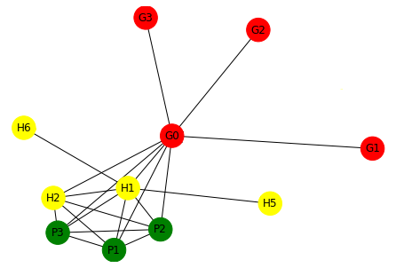

**Family is important**

Further police investigation showed that some of the police officers, healthcare workers, and even gang members had family members. We'll prefix family member nodes with the letter "F":

**A sordid twist to the story**

After interviewing family members and friends of some of the gang members, the police found that one of the gang members, G3, frequented a brothel... so now we have to track brothel workers with whom G3 might have had contact. Let's label brothel workers nodes with 'B':

This is the song that never ends...

As it turned out, some of the sex workers also had families, and other clients, and friends, and other people that they interacted with. Police officers who were on the scene interacted with their coworkers. The Ebola virus will keep spreading, and the graph will keep growing.

**The Problem**

After successfully contact-tracing and alerting people of a possible epidemic, scientists are gathering more data to predict how fast the virus will spread, and Dr. Wilkinson needs your help.

Dr. Wilkinson wants to find out how many people will be infected on the **7th** day of the epidemic. From other sources, you have been told that, **on average, one sick person infects from one to two other people**[3]. **Let’s say two**, for this exercise. You have been told that there’s a formula—the formula for Exponential Growth—that can help predict how many people will be infected at a certain point:

***Formula for Exponential Growth***

x(t) = x0 * bt

*in which:*

* *x(t)* is the number of cases at any given time *t.*
* *x0* is the number of cases at the beginning of the epidemic.
* *b* is the number of other people that one sick person infects.

What are the steps that *Dr. Wilkinson* needs to take to find the solution?

**The Solution**

Let’s list ***all[2]*** the steps Dr. Wilkinson needs to take:

**Plain English**

***Fill in the Blanks***

**1.** Well, Dr. Wilkinson first needs you to tell her the value of the variables, of course. Because she assumes that there was *one* initial case (that is, that x0 = 1), she will not ask you about the value of x0—that’s an easy one. But she will certainly ask you about the next variable: “Okay, so tell me, on average, how many other people does one sick ____________________________?”

**2.** And you answer: “________”. *(Hint: We gave you this number on the previous page.)*

**3.** Then she needs to calculate: x(7) = ______ * ______ = ______.

**4.** Finally, she concludes, “There will be ________ infected people on the day # ________ of the epidemic.”

**Generalized Solution**

Dr. Wilkinson now wants you to code a program that will allow her to calculate how many people will be infected at *any* day of the outbreak of *any* virus.

Think for a moment: **What would the program need to know to do this? And what actions would it need to do?** Use the brainstorm space below to answer these questions.

*Note: It will be assumed that there was one initial case, so we can just forget about that variable and use the simplified formula: x(t) = bt .*

***Brainstorming space:*** ______________________________________________

______________________________________________________________

______________________________________________________________

______________________________________________________________

______________________________________________________________

______________________________________________________________

Well, the program should:

* Ask the user how many other people one sick person infects.
* Ask the user the day of the epidemic for which it should calculate.
* Calculate and let users know the result of the calculation.

We will list all the steps in detail in the next exercise, but for now, let’s introduce you to pseudocode and variables.

**Pseudocode**

Let’s start translating our solution into a language that is *similar* to the languages that computers understand. On the limbo between plain English and programming languages, there is pseudocode. For the next exercise, we will use a variation of the conventional pseudocode.

**Variables**

Computers cannot “remember” the user’s input unless you *store* this information somewhere. To do this in programming, we use variables.

You can think of variables as containers. Like a regular container, the content you put inside a variable can *vary* (thus its name!) depending on what you want it to store. And like a tag on a regular container, it is wise to give variables a distinct name that alludes to what the variable is storing (e.g. “x(t)”). Unlike a regular container, however, spaces between words and parenthesis are normally not allowed. **Thus, “x(t)” may be better expressed as “xt”.**

**Matching Pairs Game + Fill in the Blanks**

Match each action of the generalized solution in plain English (left gray column) with its pseudocode translation (right gray column). Use the options on the green chart to fill in all the blanks.

|  |  |  |  |  |  |  |
| --- | --- | --- | --- | --- | --- | --- |
| Choose from the following options to fill in the blanks: | | | | | | |
|  |  |  |  |  |  |  |
| does one sick person infect |  | exponent_result |  | X21 |  | For what day of the epidemic do you want to calculate? |
|  |  |  |  |  |  |  |
| b |  | xt |  | answer |  | B2 |
|  |  |  |  |  |  |  |
| P1 |  | G4 |  | x0 |  | t |

***Note: Some of these options will not be used, and some may be used more than once.***

*Tip: If possible, keep the color-coding of the options on the green chart (e.g. “answer” is turquoise; “xt” is orange.)*

|  |  |  |
| --- | --- | --- |
| **Step-by-Step**  **Generalized Solution For Coding** |  | **Pseudocode** |
| **1.** Ask: “On average, how many other people ______________________  ___________________?” |  | POWER _______ ^ _______ |
| **2.** When the user answers, save this answer in a variable called “____”. |  | ASK “On average, how many other people _________________________?” |
| **3.** Ask: “_______________________  ____________________________” |  | ASK ____________________________  ______________________________ |
| **4.** When the user answers, save this answer in a variable called “____”. |  | SAY “There will be _____ infected people on the day # _____ of the epidemic.” |
| **5.** Calculate: _____ ^ _____ |  | SET xt TO exponent_result |
| **6.** … and save the ***result*** of the calculation in a variable called “xt”. |  | SET b TO __________ |
| **7.** Communicate to the user: There will be _______ infected people on the day # _______ of the epidemic. |  | SET t TO __________ |

***Reorder the Pseudocode***

Now that you have matched each step with its pseudocode translation, write the whole pseudocode below in the right order.

*Remember to write each step in a different line. If possible, keep the color-coding of the pseudocode lines above. (E.g. “ASK” is turquoise; “SET” is orange.)*

_______________________________________

_______________________________________

_______________________________________

_______________________________________

_______________________________________

_______________________________________

_______________________________________

_______________________________________

_______________________________________

_______________________________________

Tab 2

**Getting Started**

**1.** Open Scratch (<https://scratch.mit.edu/>) and create a free account.

**2.** Follow this link: https://scratch.mit.edu/projects/573368084/editor to open the Exponential Growth project template. **Do not edit this template!**

**3.** **Create a copy** of this template by clicking on *File > Remix*. Work on your new copy (remix) from now on.

**Coding on Scratch**

**1.** Let’s start by familiarizing ourselves with Scratch:

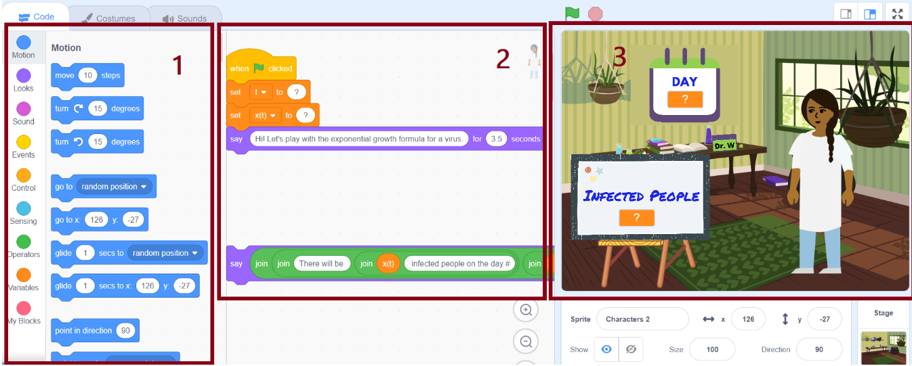

1. The first block (left) contains all the possible lines of code you can use on Scratch. The menu on the far left shows the different categories of code (“Motion”, “Looks”, “Sound”, etc.)
2. The second section (middle) is “your workspace”. This where you write your code by dragging your chosen coding blocks from the first section.

Right now, you should see four lines of code we have pre-written for you. Do you recognize the last line? (Ignore all those “joins”.) What about the first four lines—can you guess what they do?

1. The third block (right) will show the end result of your code.

**2.** Create your variables.

We have created the variables “t” and “xt” for you. Create the variable “b” by clicking on *Variables > Make a Variable.* Create the variable for all sprints.

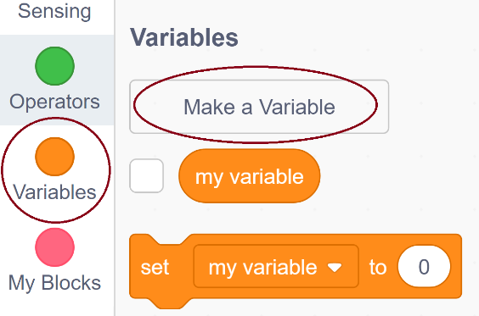

**3.** Let’s code!

Look at your workspace. We have helped you with the first four lines of code (which are not in your pseudocode) and the last line of code (which is also the last line in your pseudocode). Your job is to fill in the code in between.

To do this, look at all the possible coding blocks listed on the left side on Scratch, and then choose those that most resemble your pseudocode. Work line by line. Part by part. The Scratch translation of your pseudocode should go right after the first three lines of code we have helped you with.

*Hint: Remember that the pseudocode lines in our previous exercises were color-coded. (e.g. “ASK” was turquoise, just as the “Sensing” category on Scratch!)*

**Some useful tips:**

* To run and stop the code:

* To add new coding blocks:

* To use variables and operators:

* To embed blocks:
  + Drag a block towards the container block. Check the highlighted area before dropping it.
* The highlighted area tells you where the block will be placed:

The new block will be inserted into the first blank space.

The whole green block will be replaced

Once you finish your code on Scratch, test it! Assume the role of “user” and insert some values. Is the program answering as you intended to? Revise your code if necessary; test it again. Revise it until you get it right.

Happy coding!

Tab 4

**Python**

***Matching Pairs Game + Fill in the Blanks***

Match each action of the generalized solution in plain English (left gray column) with its Python equivalent (right gray column). Use the options on the green chart to fill in all the blanks.

***Note: Some of these options will not be used, and some may be used more than once.***

|  |  |  |  |  |  |  |
| --- | --- | --- | --- | --- | --- | --- |
| Choose from the following options to fill in the blanks: | | | | | | |
|  |  |  |  |  |  |  |
| does one sick person infect |  | bt |  | x0 |  | For what day of the epidemic do you want to calculate? |
|  |  |  |  |  |  |  |
| b |  | xt |  | answer |  | t |

**Not all options in the right gray column will be used.**

|  |  |  |
| --- | --- | --- |
| **Solution Process**  **For Python** |  | **Pseudocode** |
| **1.** Ask: “On average, how many other people _____________________  ______________?” and store whatever the user *inputs* in a variable called “b”. Additionally, specify that “b” will be an integer* number. |  | b = int(input("On average, how many people ___________________  _________________?")) |
|  |  | b = (input("On average, how many people __________________  _________________?")) |
| **2.** Ask: “_____________________  ___________________________?” and store whatever the user *inputs* in a variable called “t”. Additionally, specify that “t” will be an integer* number. |  | print ("There will be", ____, "infected people on the day #", ____, "of the epidemic.") |
|  |  | t = intg(answer("___________________  _____________________________?")) |
|  |  | b = int(input("___________________  _____________________________?")) |
| **3.** Calculate “b^t” and save the result of the calculation in a variable called “xt”. |  | t = int(input("___________________  _____________________________?")) |
| **4.** Print on screen a message that says how many infected people (xt) there will be at the time (t) that the user has chosen. |  | xt = pow(b, t) |

*\*Hint: The program does not know whether the user’s input will be text (which cannot be used for mathematical operations) or numbers (which can be used for mathematical operations). Thus, you need to specify what type of input (text, integers, decimals) the program should expect.*

***Reorder the Code***

Now that you have matched each step with its Python equivalent, write the whole Python code below in the right order. Don’t forget to copy every letter and

punctuation mark exactly as they are above—every character matters in coding!

_______________________________________

_______________________________________

_______________________________________

_______________________________________

***Run Your Code***

**1.** Open Jupyter Notebook: <https://jupyter.org/try>

**2.** Open JupyterLab and wait a few seconds for it to load.

**3.** Click on “Python 3” under “Notebook”.

**4.** Type the Python code you wrote above into your workspace.

**5.** Click on the Play button to run your code and test it. If necessary, revise your code until you get it right.

**6.** Congratulations! You just coded the Exponential Growth Formula in Python.

References

[1] Wikipedia Contributors, “Western African Ebola Virus Epidemic,” *Wikipedia*, 12-Dec-2021. [Online]. Available: https://en.wikipedia.org/wiki/Western_African_Ebola_virus_epidemic. [Accessed: 15-Dec-2021].

[2] M. Grandjean, “Connected world: Untangling the Air Traffic Network,” *Martin Grandjean*, May-2016. [Online]. Available: http://www.martingrandjean.ch/connected-world-air-traffic-network/. [Accessed: 15-Dec-2021].

[3] WHO Ebola Response Team, “After Ebola in West Africa — Unpredictable Risks, Preventable Epidemics,” New England Journal of Medicine, vol. 375, no. 6, pp. 587–596, 2016. [Online]. Available: https://www.who.int/ebola/publications/nejm-after-ebola.pdf. [Accessed: 15-Dec-2021].

1. [2] http://www.martingrandjean.ch/wp-content/uploads/2016/05/airports-map-small.png
2. Trust us. This will be important later.